
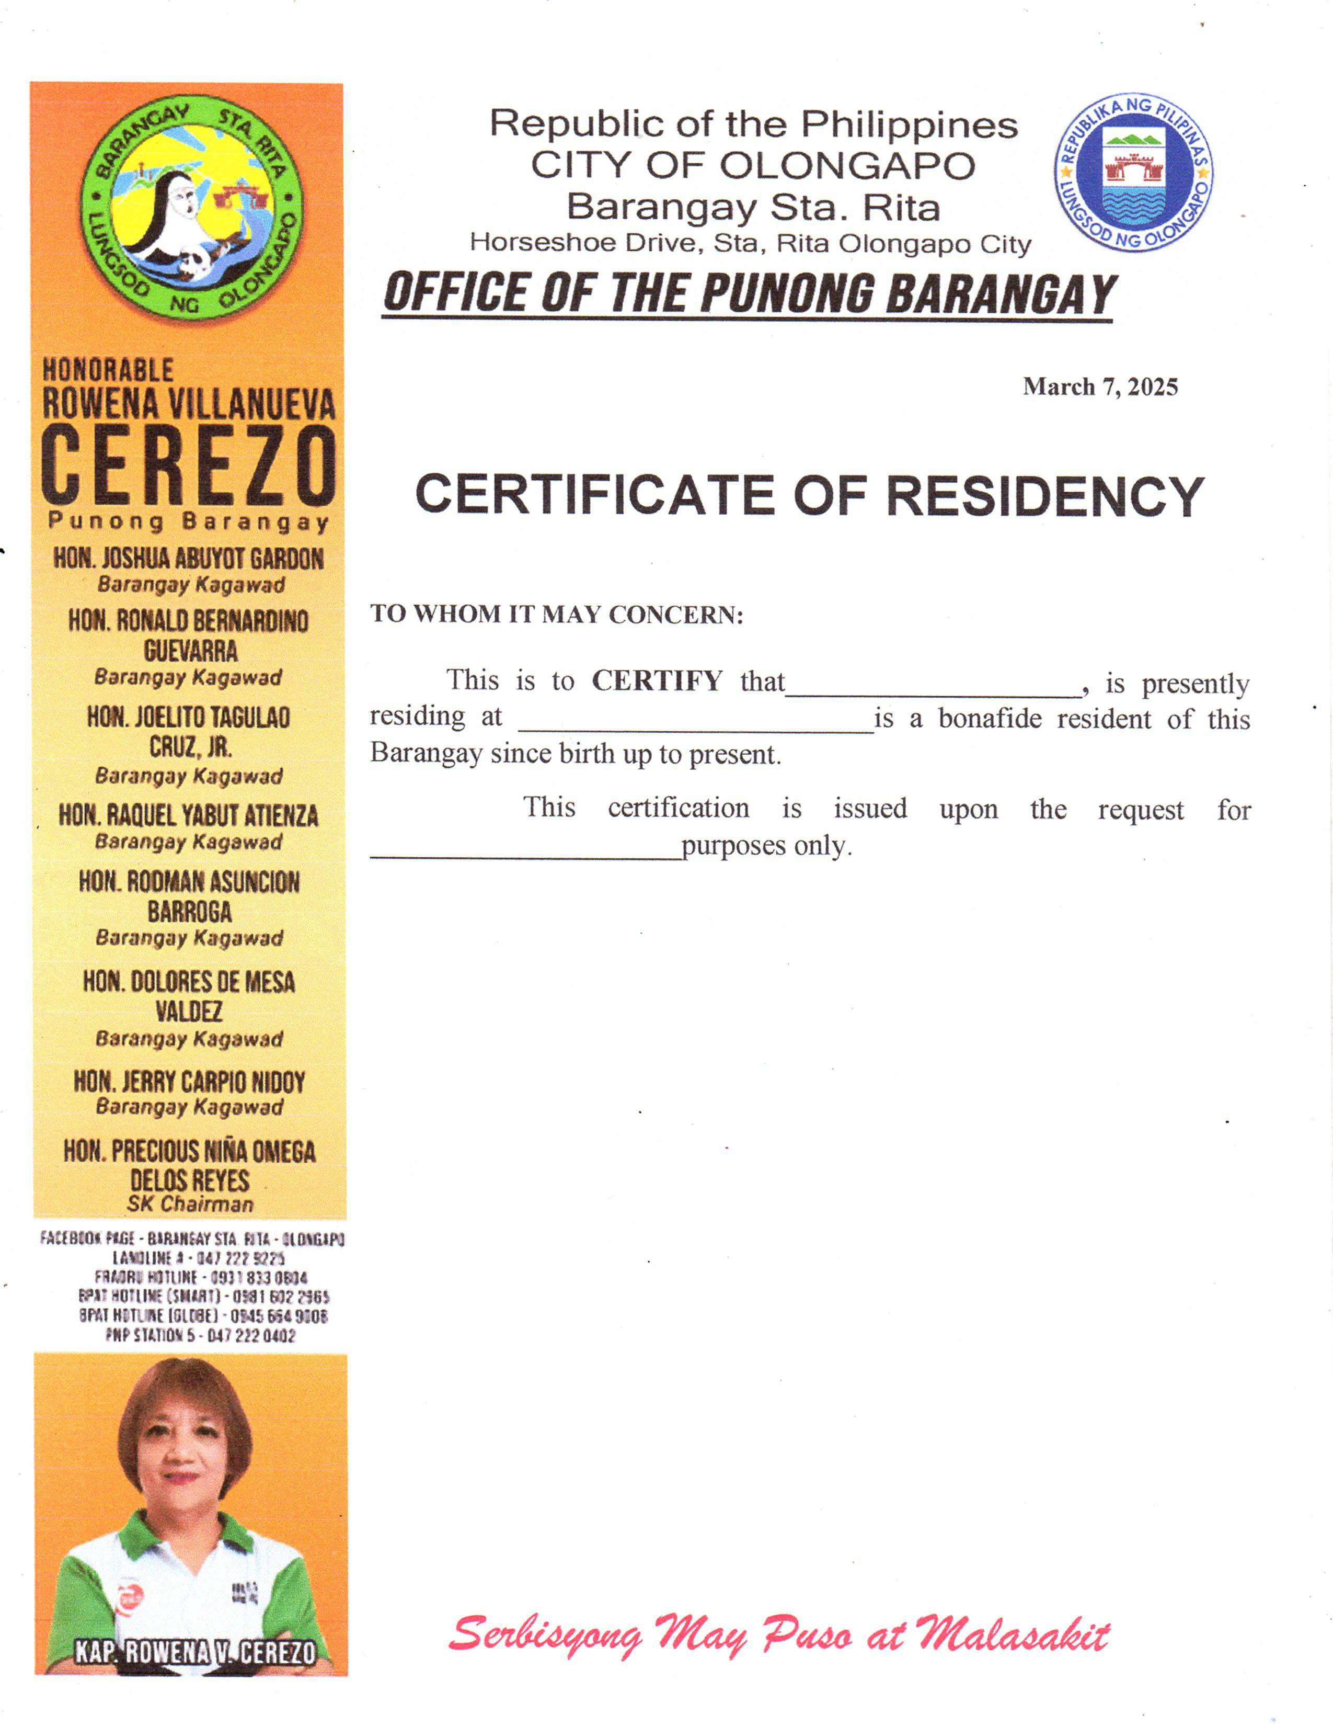
Republic of the Philippines CITY OF OLONGAPO Barangay Sta. Rita Horseshoe Drive, Sta. Rita Olongapo City OFFICE OF THE PUNONG BARANGAY
{dateRequested}

CERTIFICATE OF RESIDENCY

TO WHOM IT MAY CONCERN:
This is to CERTIFY that {fullName}, is presently residing at {address} is a bonafide resident of this Barangay since birth up to present.

This certification is issued upon the request for {purpose} purposes only.

